

Lydbrook Primary School

Calculation Policy

At Lydbrook Primary School, calculation procedures are taught according to this document so they can be seamlessly built upon year after year, as the child moves through school.

The policy has been taken and adapted from White Rose Maths. We have found their calculation policy to be the one which works for the needs of our children and suits the way in which we teach Maths. The use of concrete resources and visuals underpins this calculation policy.

Addition, subtraction, multiplication and division are broken down into skills for the year group and shows recommended models and visuals to support the teaching of the corresponding concepts alongside.

# Addition

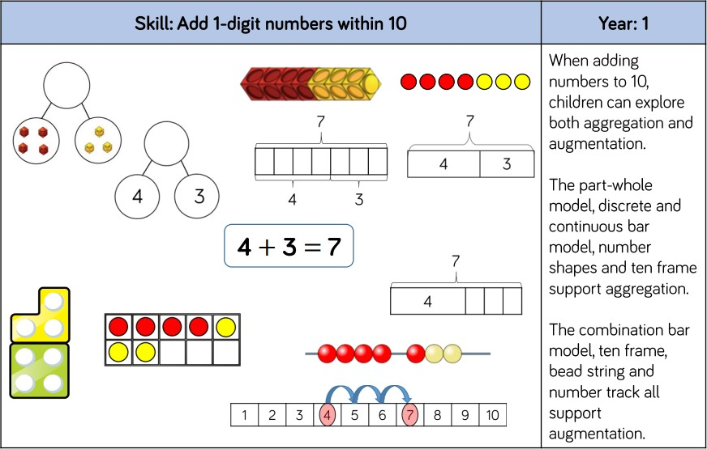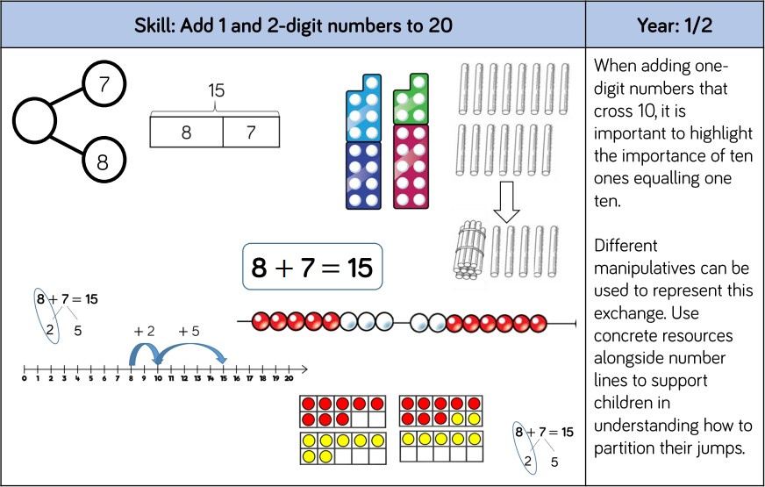

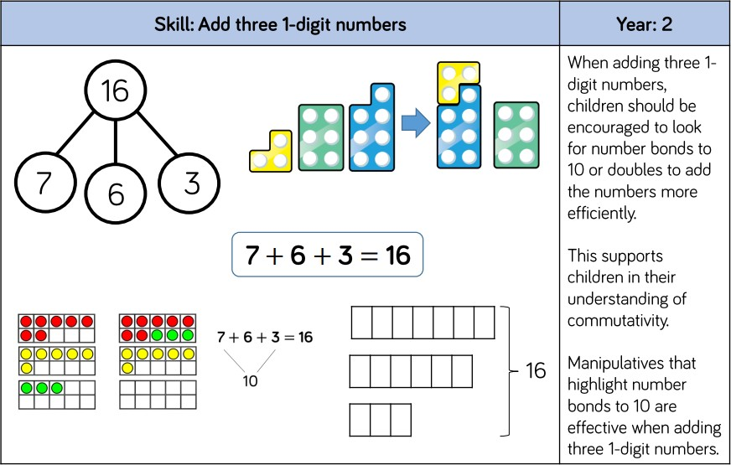

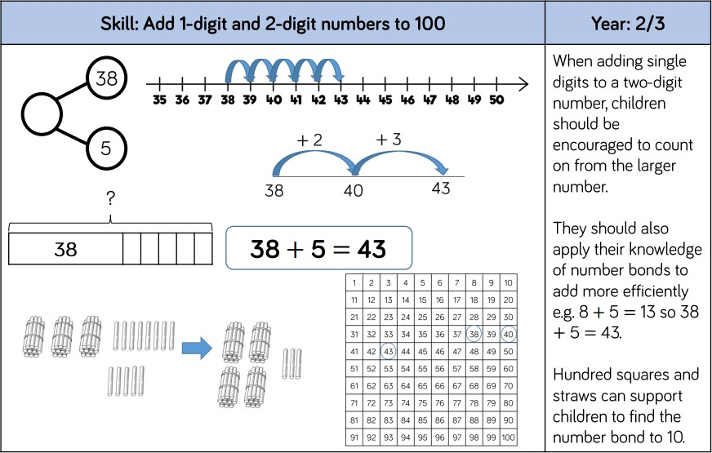

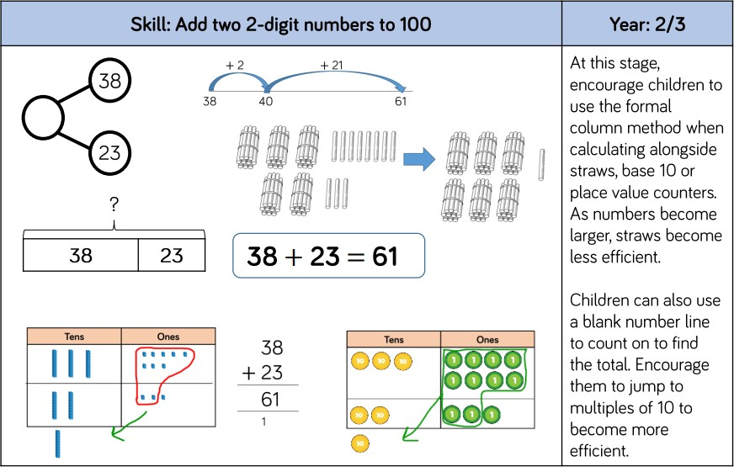

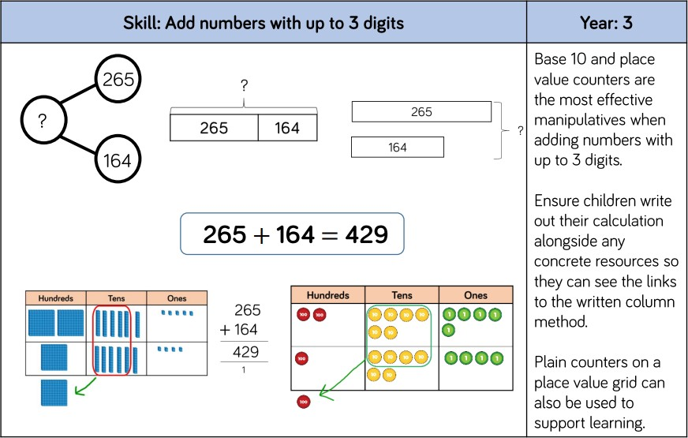

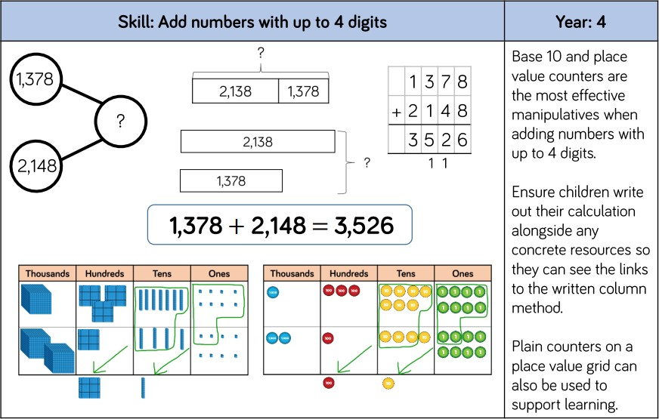

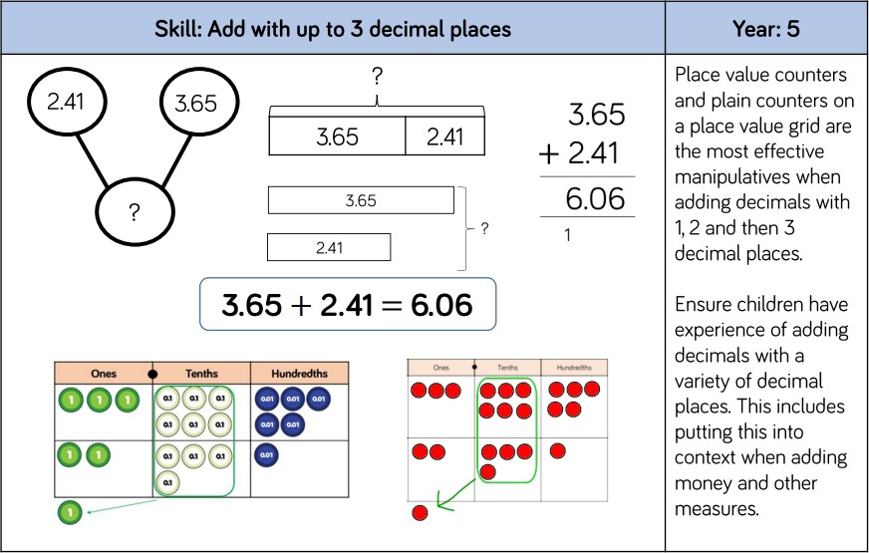

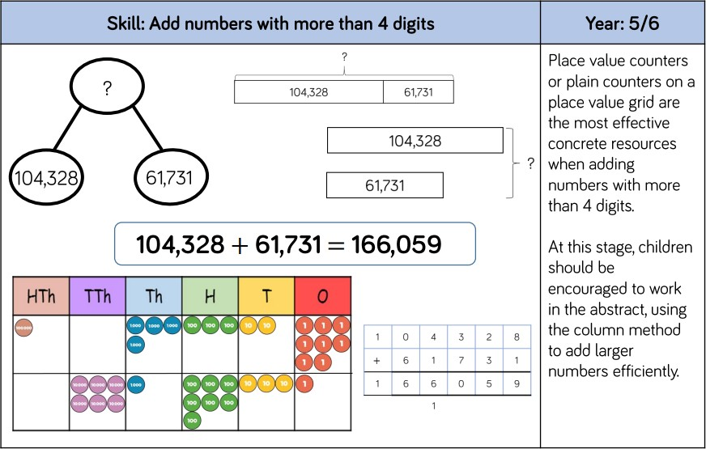

Subtraction

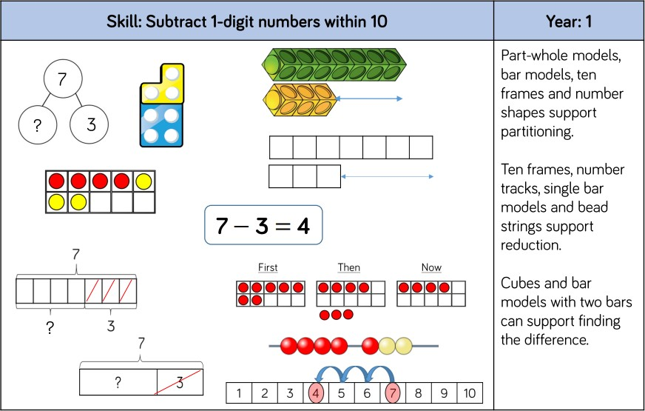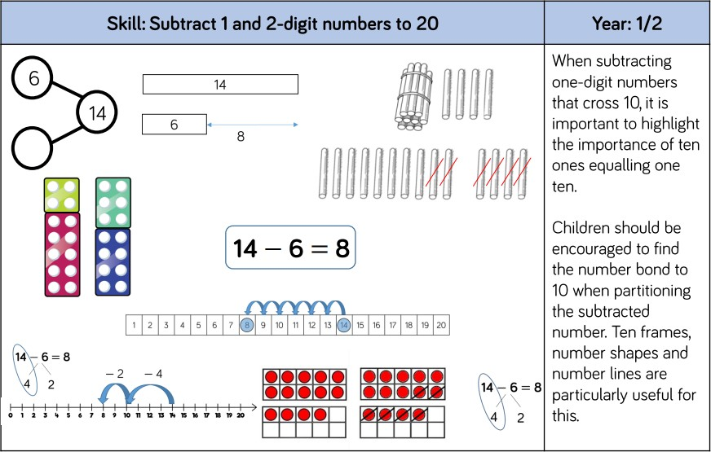

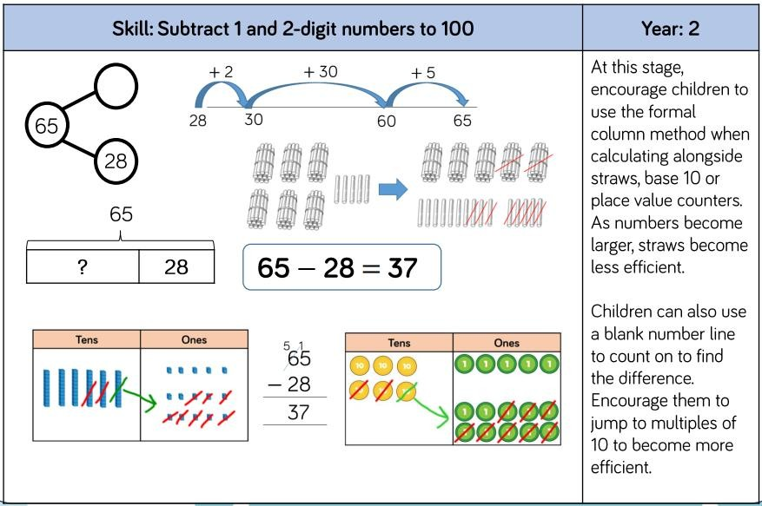

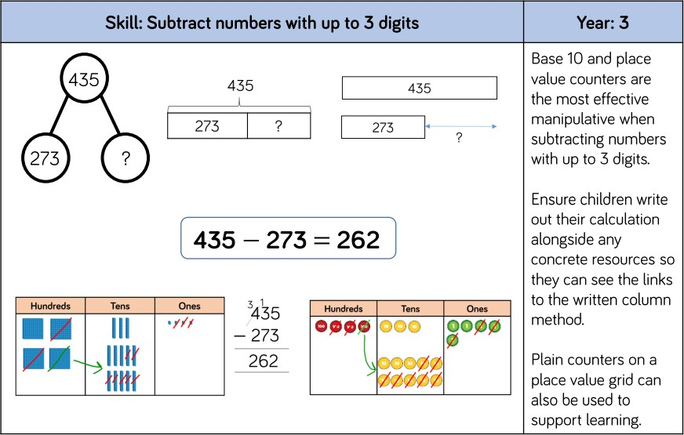

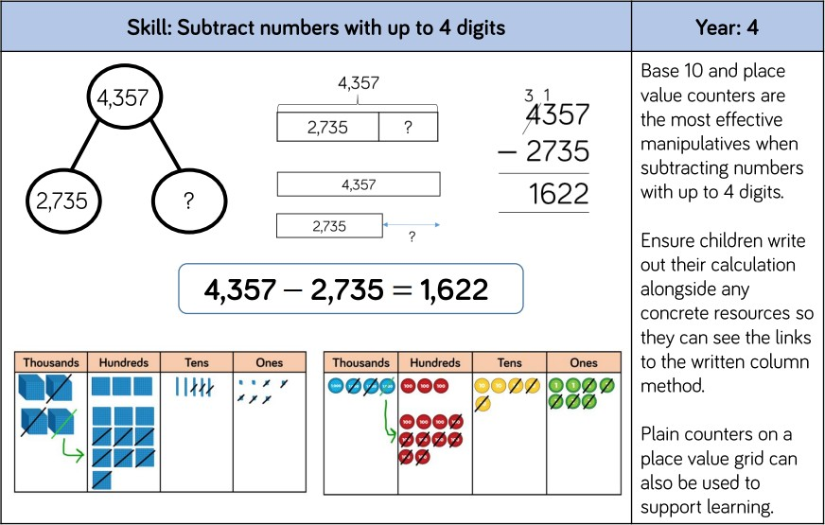

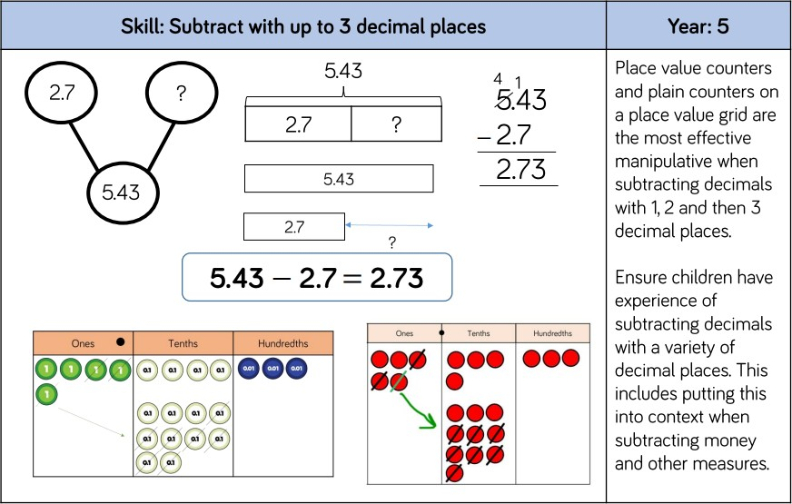

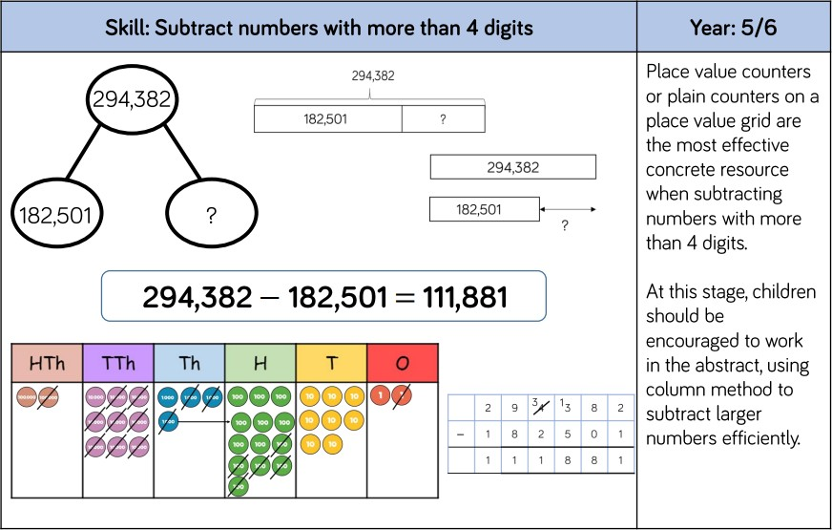

# Multiplication

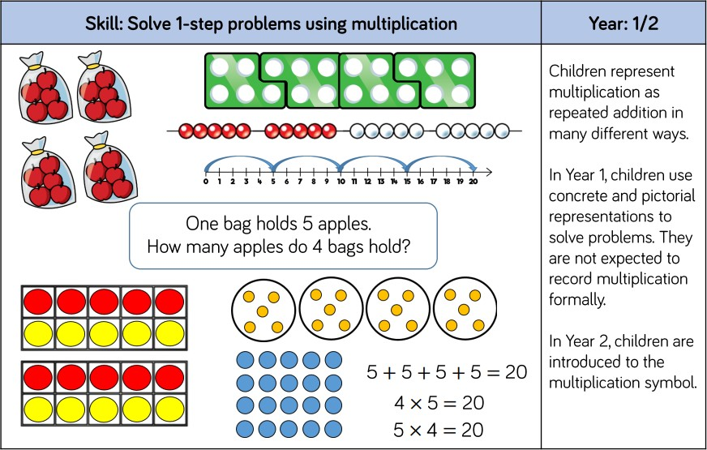

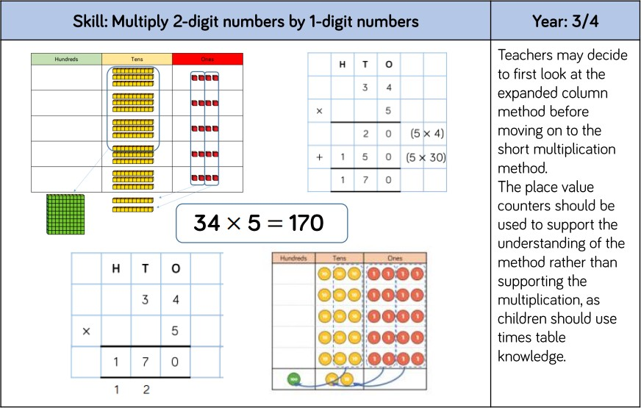

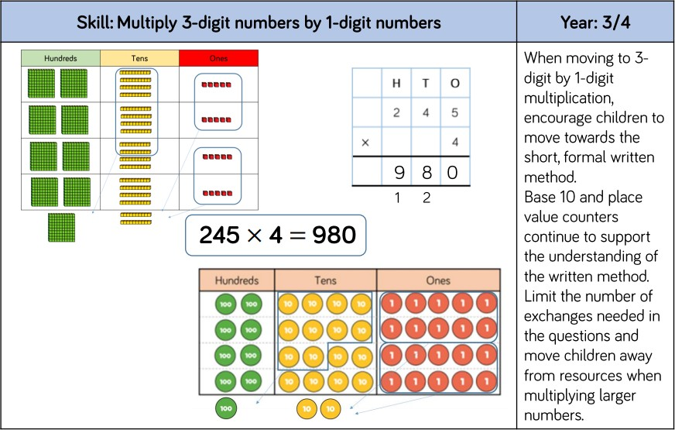

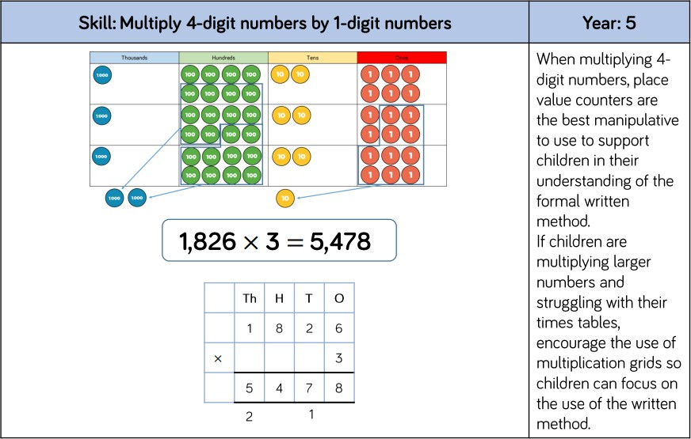

|  |  |
| --- | --- |
| **Skill: Multiply 2-digit numbers by 2-digit numbers** | **Year: 5** |
| Diagram  Description automatically generated with medium confidence  2 x 1 = 2  20 x 1 = 20  2 x 30 = 60  20 x 30 = 600    Table  Description automatically generated with low confidence  4 x 2 = 8  30 x 2 = 60  200 x 2 = 400  4 x 30 = 120  30 x 30 = 900 + 100 carried = 1000  200 x 30 = 6000 + 1000 carried = 7000 | When multiplying a multi-digit number by 2-digits children will use a formal written multiplication method.  If required, children can use a multiplication square to support them when learning the formal method. |

# Division

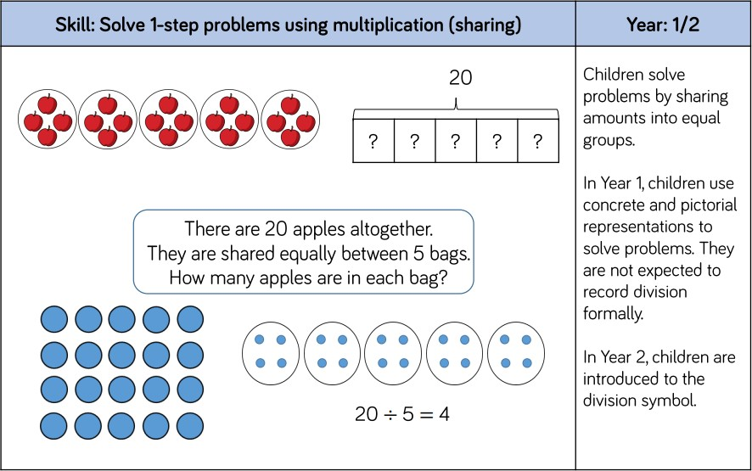

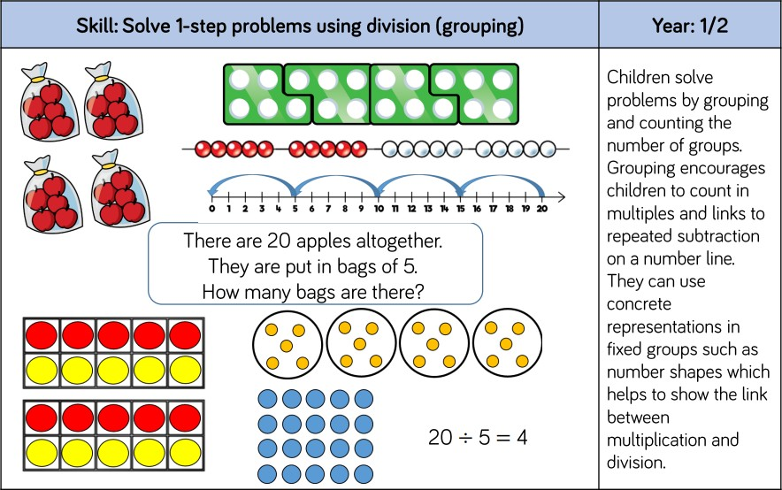

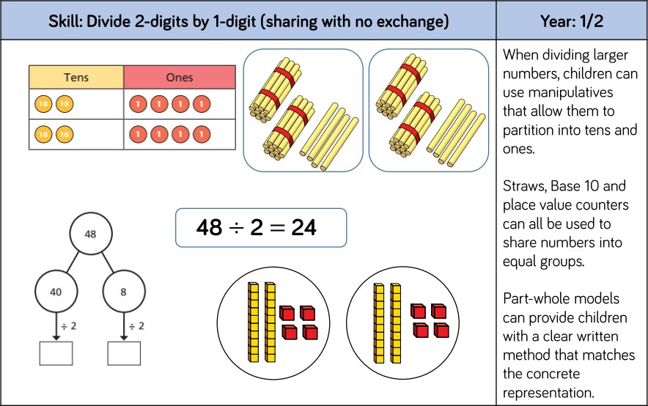

**Year: 2**

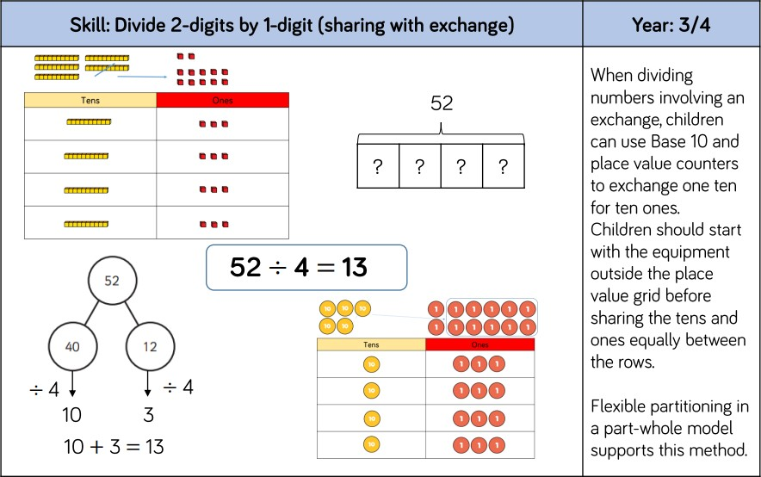

**Year: 3**

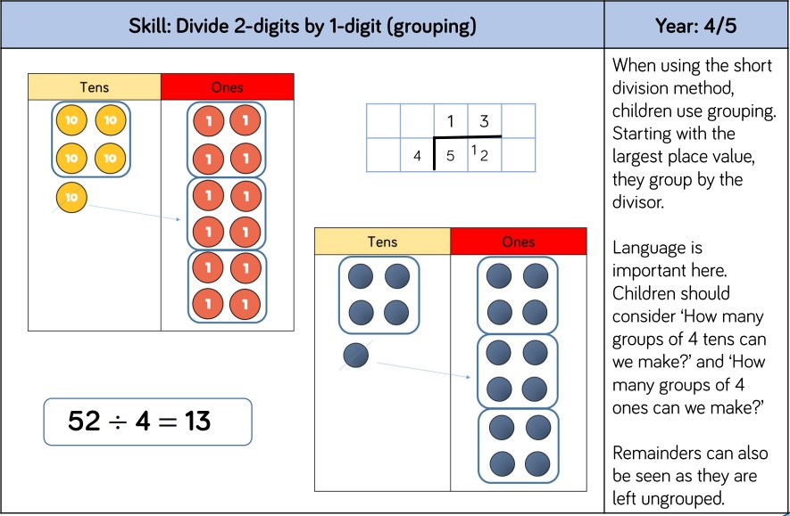

**Year: 4**

|  |  |
| --- | --- |
| **Skill: Divide 2-digits by 1-digit with remainders** | **Year 4** |
|  | In year 4, children are introduced to whole number remainders. |

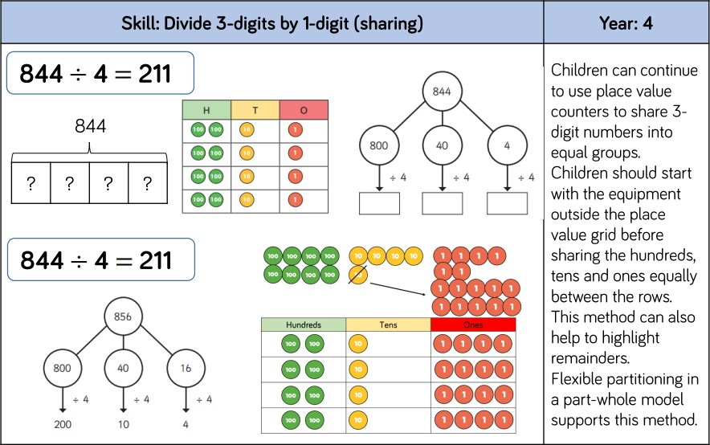

When children have mastered dividing 3-digit numbers by a 1-digit number, children will apply their understanding to unequal grouping with whole number remainders.

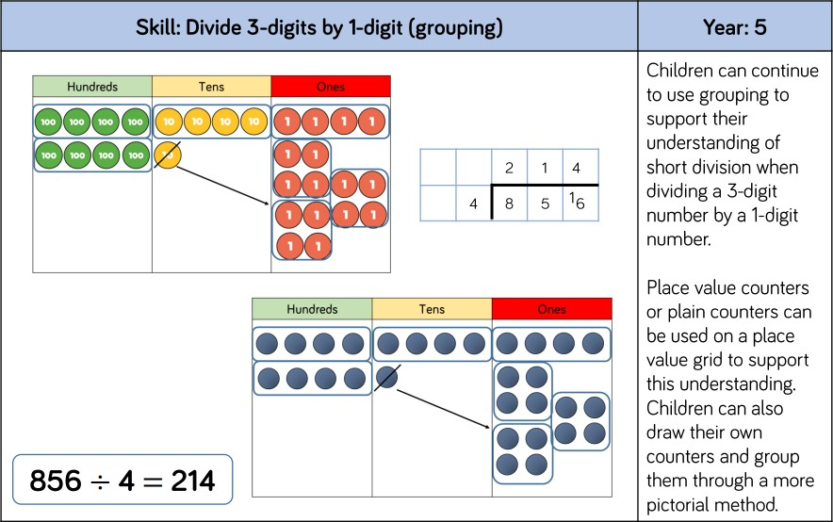

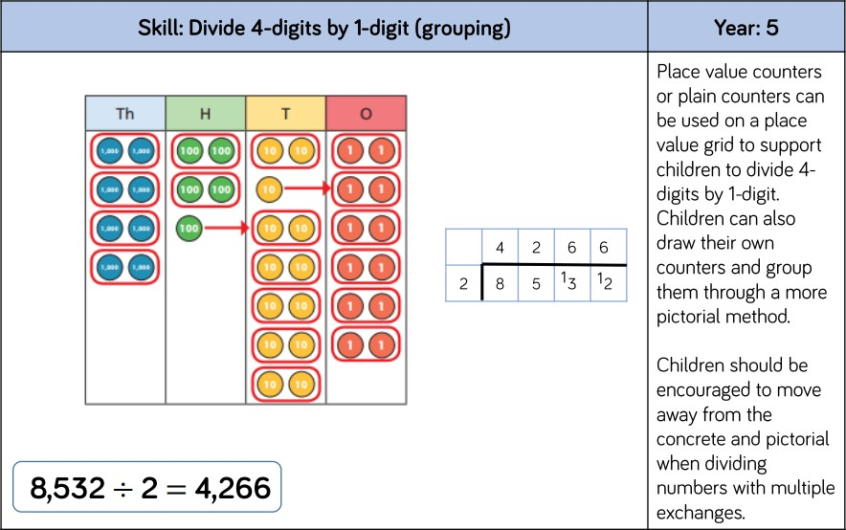

In Year 5, pupils interpret non-integer answers to division by expressing results in different ways according to the context, including with remainders, as fractions, as decimals or by rounding (for example, 98 ÷ 4 = 4 98 = 24 r 2 = 24 2 1 = 24.5 ≈ 25).

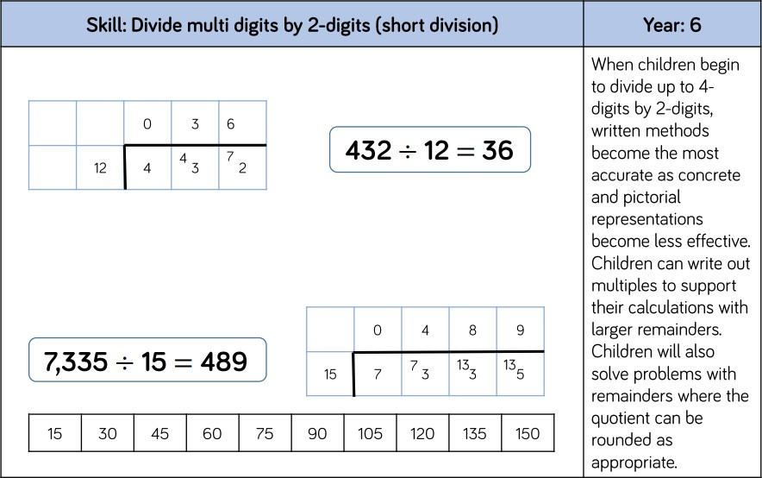

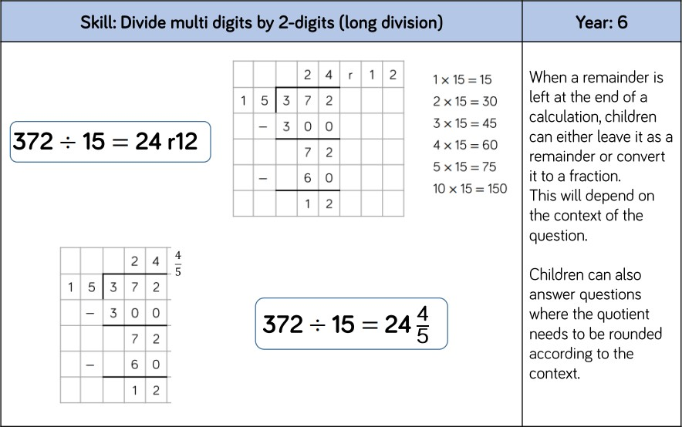

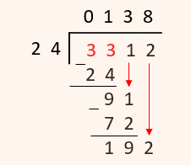

In Year 6, children are introduced to long division when dividing up to 4-digit numbers by a 2-digit number. Children can write out multiples to support their calculations.

When a remainder is left at the end of a calculation, children can leave it as a whole number remainder or convert it to a fraction depending on the context of the question.