Hawks A Forest Through Time: Industrial Revolution and Mining Spring Term 2023
Areas of learning linked to the theme
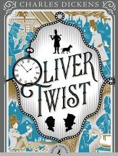  As readers we will be studying Charles Dickens' classic novel, Oliver Twist, about a young boy's adventures and mishaps in London during the early 1800s. We will enjoy reading a modern narrative version, an adapted play script as well as extracts from the original story.  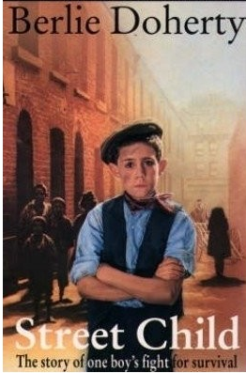  We will also read and respond to extracts from Berlie Doherty’s Street Child.  Through our reading of these texts, we will develop our reading comprehension skills linked to ‘The Totally Pawsome Gang’ including inference, vocabulary (the meaning of unfamiliar words) and prediction. We will also use the texts as historians to evaluate descriptions of Victorian Britain and compare them to other historical sources.  We will read and respond to the lyrics of a local Forest Dialect Folksong ‘Vorest Miner.’ We will learn this as a poem to perform in our class assembly. | As design and technologists we will explore the work of the famous Victorian engineer Isambard Kingdom Brunel and his pioneering designs for bridges. We will look closely at old pictures of Lydbrook Viaduct and investigate the reasons behind the arch and lattice truss design. As designers, children will use the process of TASC (thinking actively in a social context) to design, make and evaluate their own bridges.  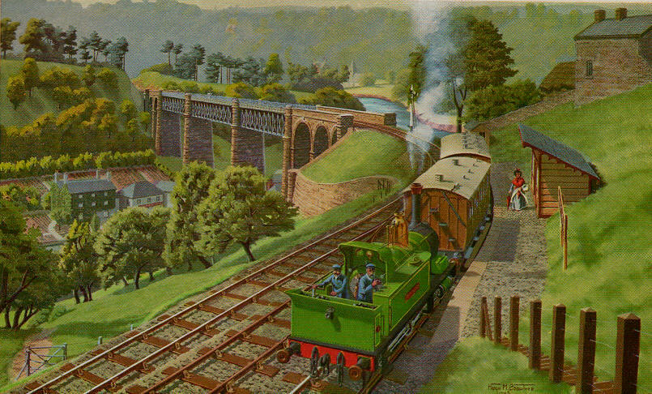  An oil painting by H.Crowther of Lower Lydbrook. 1800 |  | 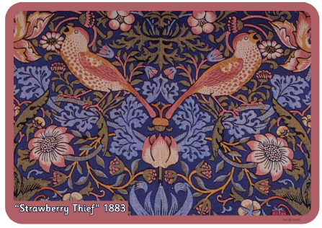  As artists we will learn about the work of William Morris, exploring the Arts and Crafts Movement of the late 19th century that emerged as a reaction to the effects of industrialisation.  Children will explore Morris’ work through practical activities including completing still-life sketches of the objects that provided the inspiration for his designs.  The children will then use their sketches to design and make a printing block. |  | As historians we will develop our ability to investigate and interpret the past by exploring a range of sources to investigate and develop our understanding of the process of industrialisation and how it impacted on the lives of people including those who lived in the Forest of Dean.  - What technological innovations led to the Industrial Revolution?  - How did industry and transport change during the Industrial Revolution, and how did these affect the rich and poor?  - Why did towns and cities grow during and after the Industrial Revolution?  - How did Victorians change the way we care for the poor and what was life really like inside workhouses?  - What was life like for working Victorian children?  Throughout our journey we will investigate the industrial heritage of the Forest of Dean, finding out how our special area of the U.K. has contributed to the growth and industrial development of our country. We will investigate:  - Why does the forest of Dean have a rich and distinct industrial history?  - What was it like to work at Lydbrook Tinplates?  - Who were David and Robert Mushet and what is their legacy?  - How was coal, ore and stone transported out of the Forest?  - What was it like to be a Forest Miner and are there any Freeminers left in the forest?
As geographers we will use our geographical skills to identify the physical features of our local area, including how the Forest has been shaped by its unique geology and physical isolation between two rivers, which first attracted people to the area and subsequently to industrial activity.  Children will learn about how, during the Victorian Era, Britain became the most powerful country in the World through the British Empire. Children will use maps to identify the vast expanse of the British Empire during the Victorian Era. | As writers we will be inspired by the texts that we read as well as our historical enquiries to inspire us to write across a range of genres including:  - Persuasive letter  - Narrative  - Recount (diary extract)  - Newspaper report  - Balanced argument
Hawks |  | School Drivers |  | Spring Term 2023
Wellbeing  We will begin our PSHE learning this term by exploring ‘Dreams and Goals’ where we will identify personal learning goals.  Later in the term, we will be exploring ‘Healthy Me’ where will investigate the importance of looking after our physical and mental health. |  | Growth Mindset, Possibilities and Aspirations  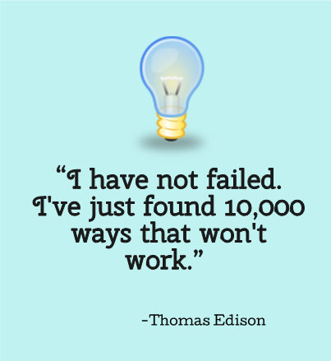  We will learn about the resilience and Growth Mindset of famous inventors during the Industrial Revolution including Thomas Edison. We will link this to our learning about ‘The Learning Pit’ and the importance of one of our ‘Secrets of Success’, resilience, in achieving our own dreams and goals. |  | Community  We will connect with local Freeminers and take a guided tour of Hopewell Colliery to find out more about coal mining in the forest.  We will interview a member of our community whose relative survived the Lydbrook Waterloo Pit disaster of 1949.
Enterprise including Language  We will continue to build on our learning partner culture within the classroom where children cooperatively discuss, answer questions, learn from each other and effectively give peer feedback.  During class discussions, we will use our established ‘talk tactics’ during class and learning partner discussions to build, summarise and challenge ideas. We will continue to build our confidence with using talk tactics to instigate new ideas into discussions and to clarify others’ ideas.  Children will engage with regular ‘Picture News’ materials to learn about current world events and to support them in using their oracy skills to discuss thought-provoking questions linked to topical issues. |  | Eco and Environment  We will learn about how, since the start of the Industrial Revolution, burning fossil fuels, including coal and oil, have increased greenhouse gas concentrations in our atmosphere.  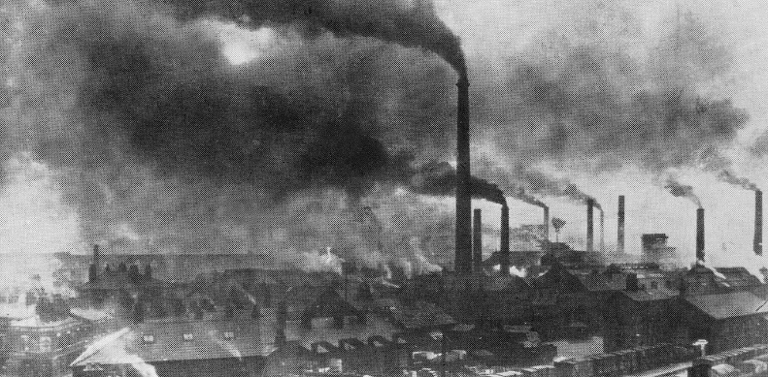 |  | 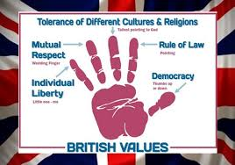  Diversity including British Values  We will use Picture News to learn about current events in the UK and around the world, and relate these to the British Values of democracy, the rule of law, mutual respect, individual liberty and tolerance of those with different faiths or beliefs.  Democracy: We will continue to hold class council meetings where the children will discuss and vote on key matters within school.

Hawks Areas of Learning not linked to the theme Spring Term 2023
Maths  Decimals, fractions and percentages:  Children will revise decimal place value and learn how to convert between fractions, decimals and percentages. They will then learn how to calculate percentages of amounts.  Fractions:  Children will further develop their understanding of equivalent fractions and fractions that total more than one. When learning about calculating with fractions, children will discover how to add, subtract, multiply and divide fractions, simplifying their answers where possible.  Statistics:  Children will learn to read and interpret data represented in tables, line graphs and pie charts. | Science  Evolution and inheritance:  The children will learn how animals and plants have adapted to suit their environments. They will develop their understanding of Charles Darwin’s theory of evolution before examining scientific evidence from plants and animals that has been gathered to support the theory of evolution.  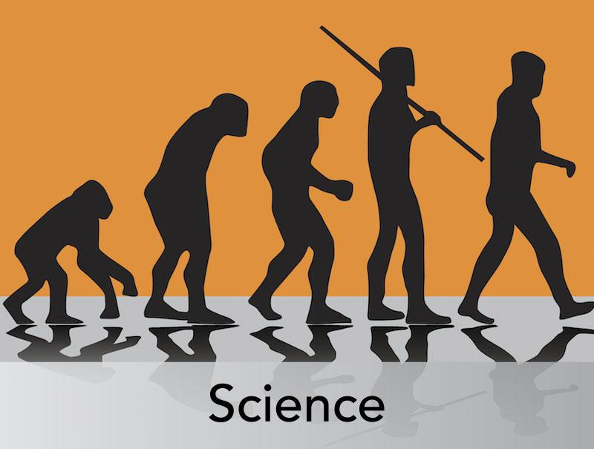 | French  Children will be developing their vocabulary by learning the French numbers 1-31, the days of the week, the months of the year, dates and seasons.
RE

Mrs. McIntyre will be exploring the following question as a basis for the children’s RE work this term: Why do Hindus want to be good?
Music
Advanced rhythms: Children will explore rhythmic patterns in order to build a sense of pulse before applying this understanding to create their own compositions.
 | Computing  Spreadsheets: Children will learn how to organise data into columns and rows to create their own data set. They will be taught the importance of formatting data to support calculations, while also being introduced to formulas. They will begin to understand how formulas can be used to produce calculated data. | PE  Mr. Bowkett will be further developing the children’s dance and movement skills. Where possible, he will creatively link this to our theme.  On Fridays, the children will be developing their compass and orienteering skills around the school site.

