Jays |  | Land of Hope and Glory | Autumn Term 2022
The children will take a look at the geography of the UK - from the physical features of mountains, rivers and seas to the man-made administrative regions and counties. They will find out how the UK has changed over time, looking at how London grew and how the population of the UK as a whole has changed throughout the course of history.
Areas of learning linked to the theme
As readers we will be exploring books and short stories on themes based on the British Isles.  Class book: The London Eye Mystery by Siobhan Dowd: a thrilling adventure story set in London. A boy and his sister try and find their cousin who goes missing on a trip to the famous London landmark.  Poetry We will learn by heart the poetry of some Great British Poets.  Information Texts we will explore our topic through a selection of information books providing information on the theme of the UK.  We will develop our understanding of texts through comprehension activities linked to the ‘Pawsome Gang’ to ensure we have the skills we need to decipher texts.  - Inference Iggy  - Vocabulary Victor  - Predicting Pip  - Rex Retriever  - Summarising Sheba  - Cassie the Commentator  - Arlo the Author | As writers we will be learning to write a variety of styles of text using themes based on the British Isles.  Class book: We will use our class book (London Eye Mystery by Siobhan Dowd) to inspire our own stories in a similar style.  Poetry After we read and learn poetry of some Great British Poets we will use them as inspiration for our own short poems.  Information texts We will apply our geography learning to a range of information texts.  Explanation writing We will apply our learning in technology and physical geography to produce explanation texts.  Narratives We will create short stories on adventures around London. |  |  | As Geographers we will identify key geographical features of the countries of the United Kingdom, and show an understanding of how some of these aspects have changed over time.  Understand geographical similarities and differences through the study of human and physical geography of a region or area of the United Kingdom  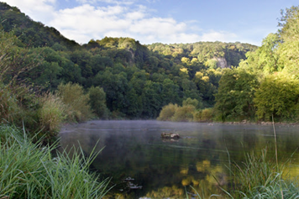
 | 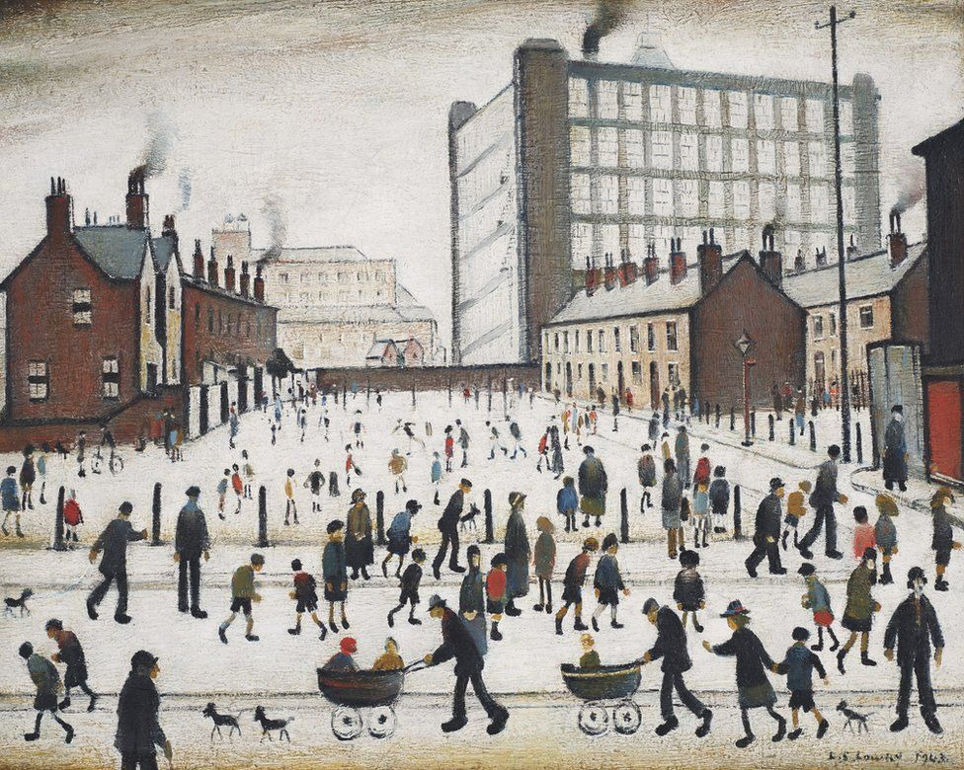  As artists we will explore the work of Great British Artists such as Lowry and Constable as well as exploring ways people have enhanced their area through art, including crochet and murals. |  |  | As designers we will apply what we learn about structures and explore how to strengthen and stabilise our structures. We will explore different ways to create buildings from blocks and shapes. We will also discover how arches are very strong shapes and we will see how architecture throughout the ages has used the arch to create stable structures and openings.  We will explore how to stiffen and strengthen materials by rolling, folding and combining them.
Jays |  | Land of Hope and Glory | Autumn Term 2022
School Drivers
Wellbeing  As part of our Well-being and PSHE we will be starting a new scheme called Jigsaw.  Using Jigsaw, we will learn to be part of a class team and how having a voice is important, as well as what motivates behaviour.  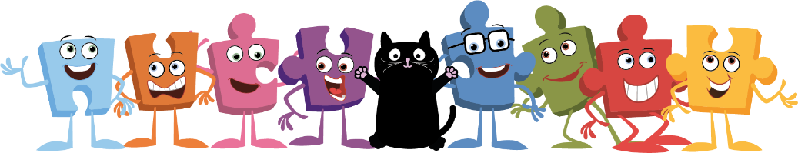 | Growth Mindset and Possibilities  As effective learners:  We will learn about the structure of the brain and how, with effort, practice and perseverance, we really can ‘grow’ our brains and learn new things.  We will develop our understanding that success isn’t easy for anyone and further develop our understanding and application of Growth Mindset principles including:  Learning from our mistakes and the power of ‘I can’t do it…yet’  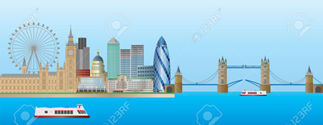 |  |  | Community  As members of our community we will -  We will explore the network of 53 independent countries called the Commonwealth.
Enterprise including Language  Through developing our language we will:-  Develop our knowledge of vocabulary to use in our own writing through exposure to texts with rich and varied vocabulary. We will use the UK KS2 Knowledge Mat to explore subject specific vocabulary.  We will continue to add interesting words, which can be used in a variety of situations, to our vocabulary tree.  Also building banks of words to our Magpie books.  We will continue our work on Voice 21 by using our sentence stems and speaking and listening guidelines when we are having our class discussions to build on each other’s ideas. | Eco and Environment  As ecologists:-  We will find out how areas of national importance are protected and conserved for future generations including our own local area.  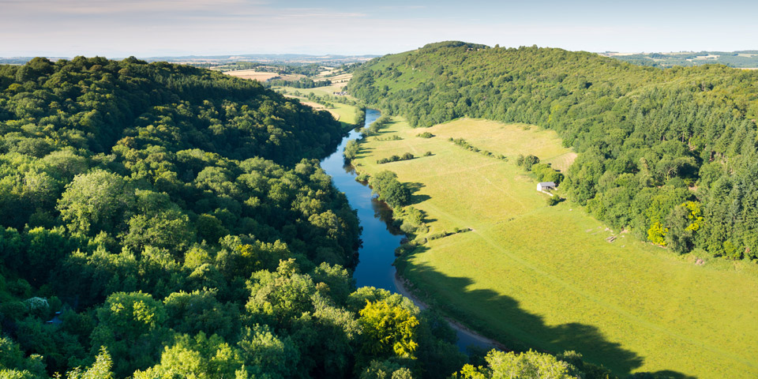 |  |  | Diversity including British Values  and Aspirations  As understanding and tolerant people:  We will develop our understanding of British values.  - democracy;  - the rule of law;  - individual liberty;  - mutual respect for and tolerance of those with different faiths and beliefs and for those without faith  We will also learn about the diverse opportunities the world has to offer to develop positive aspirations for the future.
Jays Areas of Learning not linked to the theme Autumn Term 2022
Maths  Number: We are going to understand different aspects of Place Value. We are going to be reading a writing numbers up to 1 million, as well as recognising the place value of different digits in different size numbers. We will also be exploring new and different concepts like negative numbers.  Addition and Subtraction: We will be continuing to develop on our place value knowledge by being able to use formal written methods for addition and subtraction methods for increasingly larger numbers. We will be estimating and using the inverse of calculations to check our answers for our written methods.  Multiplication and Division: We will be having Maths Passport sessions up to 3 times a week where children will be practicing their multiplication and division. We will also be looking at new methods for multiplication and division. | Science  The Year 5s, with Mr Bowkett, will be learning about difference forces we come across every day.  The Year 4’s, with Mr Lusted, will be learning about Sound. As well as this, they will be discovering the different states of matter. | French  With Mrs Russell, they will learn French adjectives of colour, size and shape; French numbers, calendars and birthdays.
RE

With Mrs Russell, children will try to answer the questions How do Christians decide how to live? What would Jesus do?

 | Computing  We will be discovering what is a website? And how information on websites are shared.  We will be recording and edit audio to create a short podcast on the UK. | PE  PE will be on a Tuesday and Wednesday each week  Our focus in PE for this term is large ball skills, where we will be practicing the skills needed to play team sports like football and basketball.  We will also be learning new skills linked to orienteering by using a compass and reading maps and apply these skills to a local geography fieldwork theme.

