Owls |  | Summer Term 1 2022
Owls Theme: Our Special School Grounds Term 5
We will follow the children’s interests by focussing on answering their questions about the environment around them, plants, and life cycles.  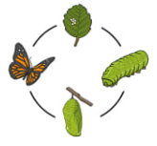  As Scientists we will explore our amazing school grounds to see what grows and lives there.  We will consider how the seasons change and how this affects us and our environment.  We will explore the different plants in our environment and learn the names of common plants and trees. We will consider how to look after our environment and grow our own butterfly gardens. Forest School sessions will provide enriching activities to encourage our learning. | As Readers and Writers we will enjoying the book The Very Hungry Caterpillar to stimulate our writing. This will lead to other stories and non-fiction texts about caterpillars, butterflies, and the immediate environment.  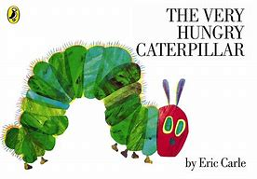  As musicians we will listen to and explore music based around nature and butterflies. We will explore percussion instruments, learning how to keep a steady beat and copy rhythms.  We will learn songs linked to our theme, such as the butterfly life cycle. | As design and technologists, we will design, make and evaluate a willow butterfly.  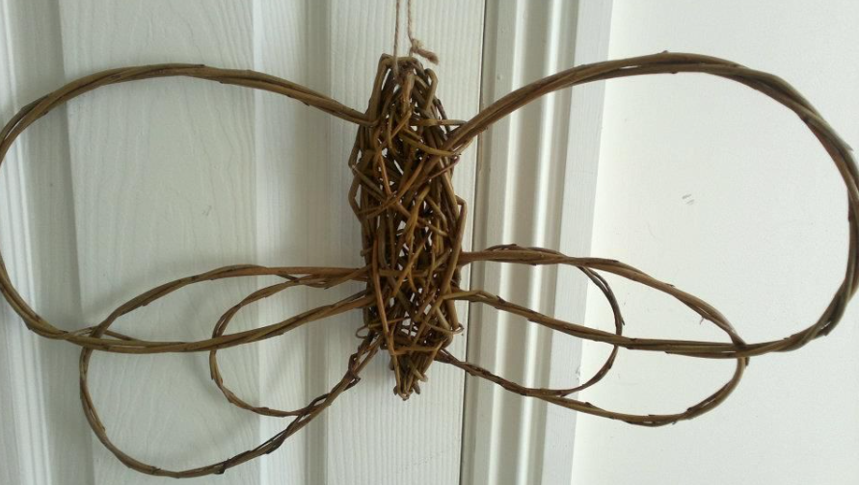  We will design, create and evaluate a decorated cupcake to celebrate the Queen’s Jubilee.
As Geographers we will look carefully at our school. We will look at the features of our school grounds and its surrounding area, drawing maps of the area and also marking on important features. We will use our maps to direct our friends around the school site. |  | As artists we will investigate the work of Andy Goldsworthy to make our own sculptures using natural materials.  The children will look at Damien |Hurst’s work focussing on “Butterfly.”  We will continue to create our own “creations” using materials available during child-initiated learning.
Owls | Our Special School Grounds | Summer Term 1 2022
School Drivers
Wellbeing  We will be linking our school grounds work when focusing on our school’s Wellbeing Garden. We will explore how being outdoors doing activities such as gardening can be beneficial to our wellbeing. We will be designing and creating our own decorative insects to display in the garden.  Linked to healthy eating, we will be thinking about the Very Hungry Caterpillar and how to make healthy choices with our eating.  As well as learning how to keep our bodies healthy through healthy eating. We will consider how to clean our teeth. | Diversity including British Values  We will look at the role of the Queen and also a simple view of the government and laws.  We will create rules based on our learning to look after and protect the outdoor environment.  The children will take an active role in celebrating the Platinum Jubilee and develop their understanding of why we will celebrate. | Community  As outward looking people, we will take part in a local coffee morning to support the local church and perform to others.  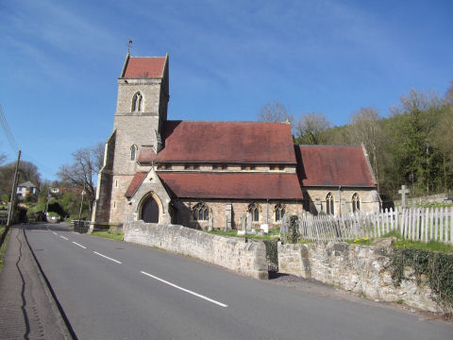
Growth Mindset, Possibilities and Aspirations  We will think about how we practice and become better at things. We will consider what we can do now and what we would like to do in the future (our aspirations).  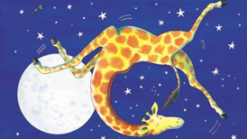 | Eco and Environment  We will explore how we can improve our school grounds, encouraging and protecting the plants and wildlife.  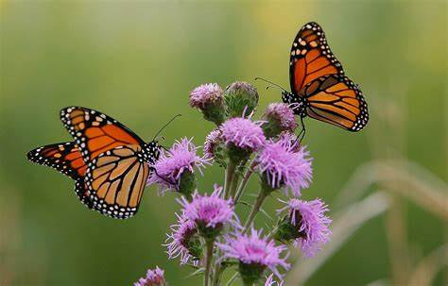  We will learn about the important way the school meadow is managed. We will think carefully about how to care for the creatures that live there, especially the butterflies and bees. | Enterprise including Language  Linked to the school’s oracy focus with the support of Voice 21, we will continue to develop our confidence to use sentence stems to agree and disagree when communicating with others.

