Charlie Cook’s Favourite Book
Owls |  | Autumn 1 2021
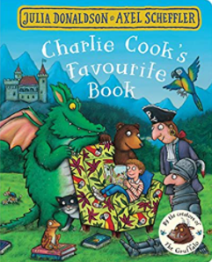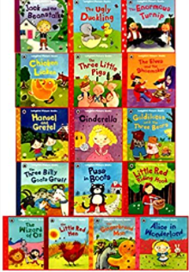  As readers we will be immersed in quality texts to support our learning.  We will be sharing traditional stories such as Goldilocks and the three bears and the Three Billy Goats Gruff. We will also be sharing stories around the themes included in Charlie Cooks Favourite Book.  Children will be learning to verbally retell stories using actions as well as creating their own stories, which they will act out to retell. We will be creating our own “helicopter stories” using our own ideas. |  | As writers we will be learning to make marks and letters.  For some children (yr1) we will be writing our own stories, instructions, and captions.  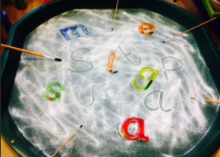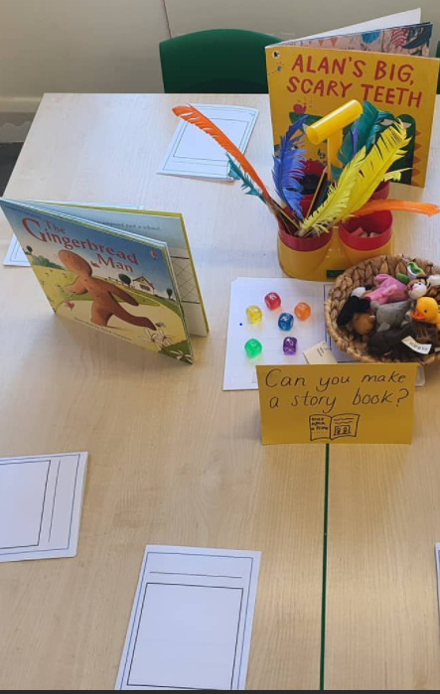
As historians will learn about castles and think about what life was like inside a castle in the past. We will think about who lived there and what their roles were. We will design and create ‘group’ castles and have a judging competition for the best castle, using features of castles we have learnt about.  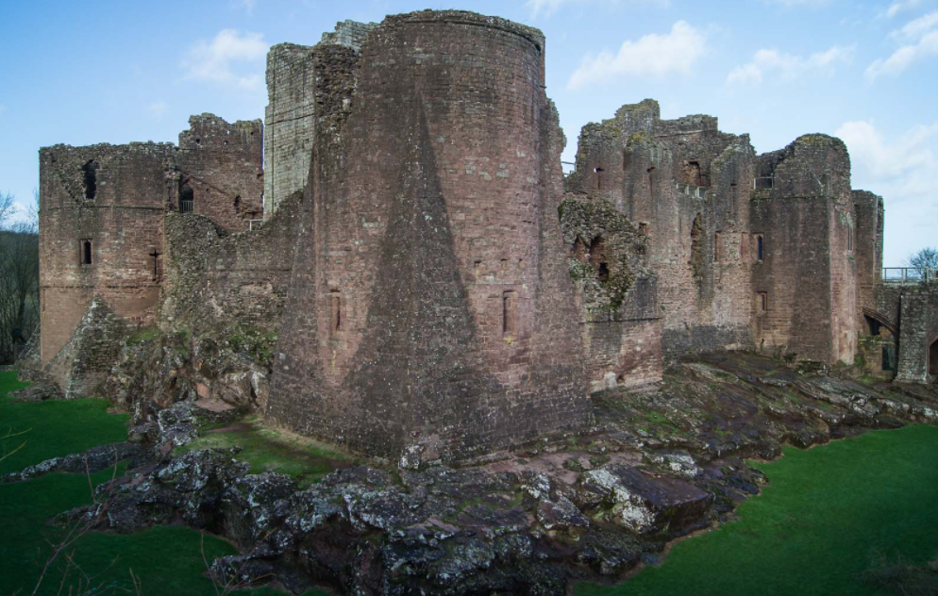 | As designers we will design, make and evaluate a shield as well as our group castles. We will develop our knowledge of joining techniques to support our independent learning. | As artists we will create images from our theme of Charlie Cook’s Favourite book and our own favourite book. We will use varied media to create images.  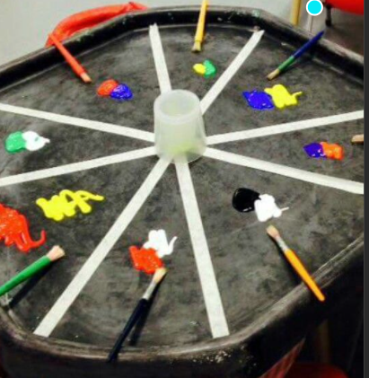  We will also explore colours and what happens when we mix colours
As musicians we will be exploring simple percussion instruments to find out how they make sounds. We will start to create and follow simple patterns.
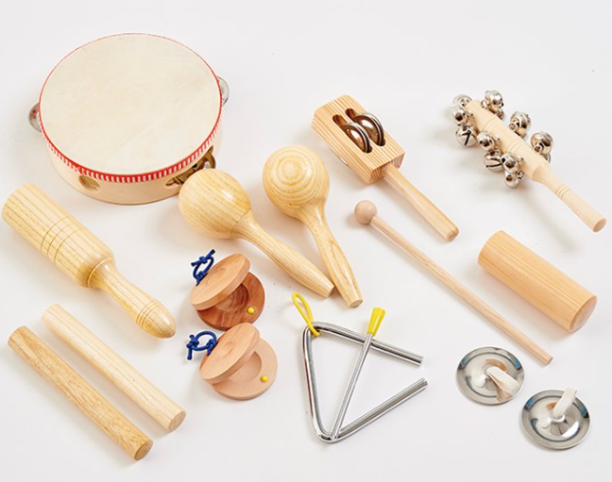

Wellbeing  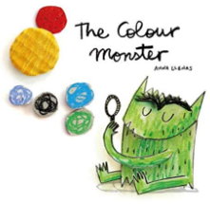 The children will be learning to identify and talk about their emotions through the story of the Colour Monster. This will become part of our everyday class language.  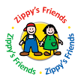We will begin the program ‘Zippy’s Friends,’ the six modules cover:  - Feelings  - Communication  - Friendship  - Conflict  - Change and Loss  - Moving forward  The children will follow the characters of Zippy the stick insect and his human owners Leyla and Tig. | Growth Mindset, Possibilities and Aspirations  We will explore the concepts of how our brains work and how we can feed them to become good learners.  We will think about how we can “have a go” at activities without being fearful as well as persevering at activities without giving up. Children will learn we have to work hard at something to become better at it.  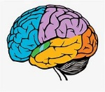 |  | Community  With COVID restrictions relaxing we will be developing our links with parents. We are hopeful this will take the form of invitation for parents to come into school to share learning and activities.  If you have any time to spare and would like to help in our classroom, through hearing us read, doing baking, craft or supporting our learning at Forest School please let Mrs Symonds know.  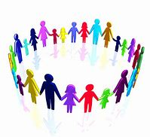
Enterprise including Language  - Language will be a focus of our term. We will be starting our NELI programme for some children to support their language and vocabulary skills. The children will start to break down the meaning of new words we find in our stories.  - We will begin to introduce speaking and listening skills linked to our whole school oracy programme Voice 21. |  |  | Diversity including British Values  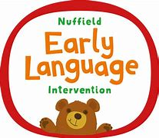  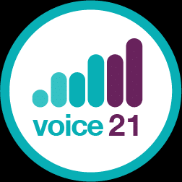  We will be welcoming new members of our class to Owls and exploring the story All are welcome.  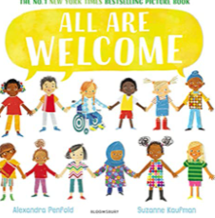  We will be exploring how  we can make simple choices  by voting e.g. for our  favourite story.

Owls Areas of learning not linked to our theme Autumn Term 2021
Maths  As mathematicians we will develop our understanding of simple number. We will be playing with numbers and counting.  Younger children will be introduced to a number of the week, whilst some learners will explore counting forwards and backwards and finding 1 more and 1 less.  We will all be making sure our 1 to 1 counting is careful and accurate.  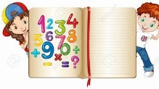  The children will find out about what happens when we add and subtract numbers.  Our learning will take place through games and play, with some older learners developing the way they record their mathematical ideas.  Maths Passports  We will send information home about Maths Passports for new reception parents.  Year 1 children will continue with their Maths Passports from last year and new information for parents will be sent home to refresh memories.  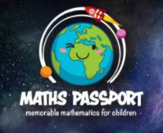 | Science/Understanding the World  Humans  We willidentify, name, draw and label the basic parts of the human body and say which part of the body is associated with each senses.  We will also begin to think about the world around us, including the plants and animals we see within the school grounds. | Computing  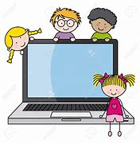  We will use IT to support our learning through simple programs on laptops and IPADS. We will learn to complete simple programs and some children will learn how to save their work.  We will develop our ability to use IPADS to record our learning through photos and videos.
RE
The children will explore festivals from different religions around the world.

We will also try to answer these questions:
1) Who do Christians say made the world?
2) Why is Christmas special for Christians

We will also celebrate Harvest by support our community.
PE/Physical development
The children will be enjoying time in the hall to practice movement linked to music as well as running, jumping and balancing.
Later in the term, the children will start our balance bike program, where they will develop their core strength and balance.
We will be focusing on our gross and fine motor skills to ensure we are ready to write and helping older learners develop their letter formation.

